Yash Mishra

Tableau Report: FINANCIAL COMPLAINTS OVERVIEW | CUMULUS FINANCIAL

- The dataset has 17 fields/ variables and 9999 records.
- The dataset contains records from December 2011 to October 2020.
- The data contains financial complaint related data for the company Cumulus Financial. It has records that contain complaint ID for each complaint, the date it was submitted and received, for which product and sub product it was raised, the issue and sub-issue, company’s response to each complaint both public and private, how was the complaint submitted, place where the complaint was raised from, if the complaint was resolved in time and was there a dispute from the consumer after the resolution.

- Following are the visualizations and descriptions for each visualization:

1.
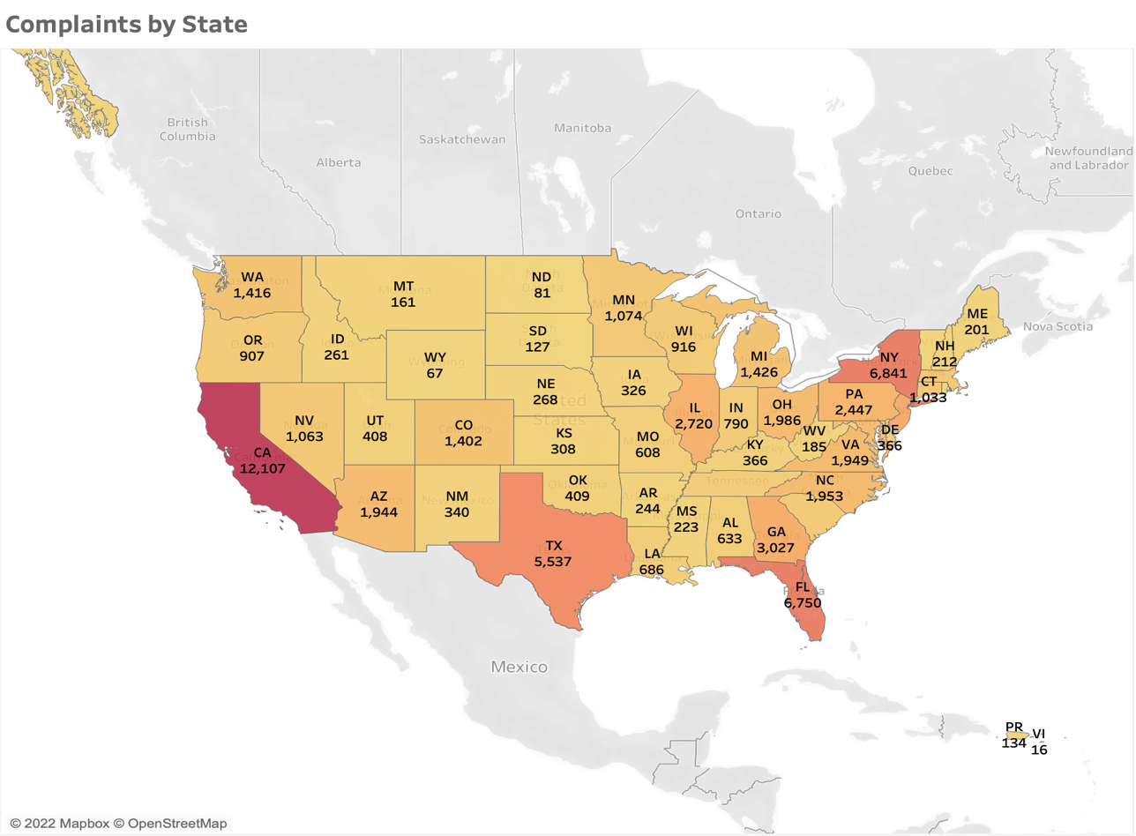

Above heatmap shows the number of complaints raised in each of the states for the US. With the above we can see which state has the most number of complaints which helps in recognizing the state that Cumulus Financial needs to work more on in order to reduce the count. From the above we can infer that Cumulus needs to focus on states like California, Texas, Florida and New York.

2.
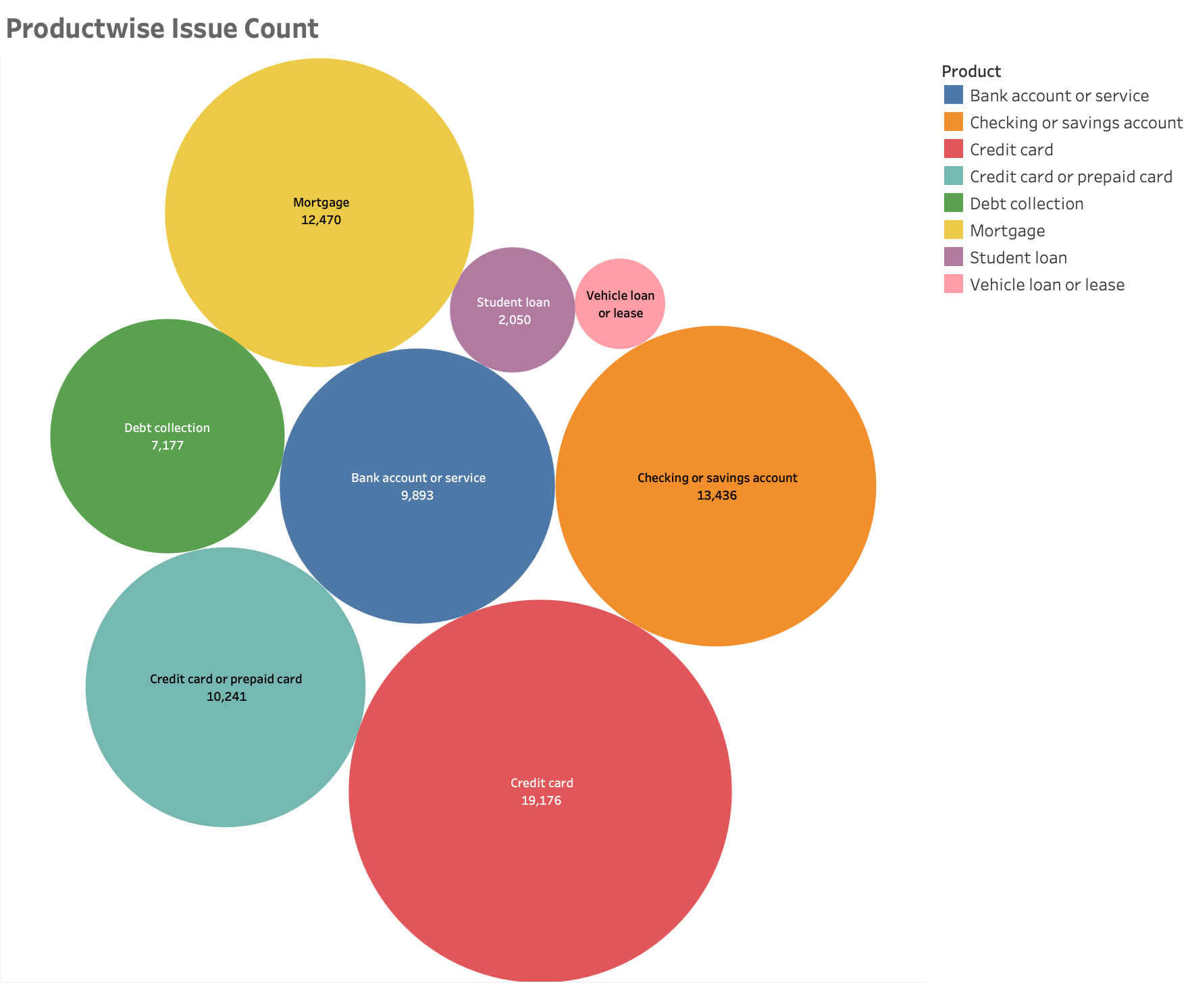

Above Packed Bubble chart shows the product wise issue count. This packed bubble chart helps us recognize the products with which consumers have more complaints and products on which Cumulus Financial needs to focus more.

3.
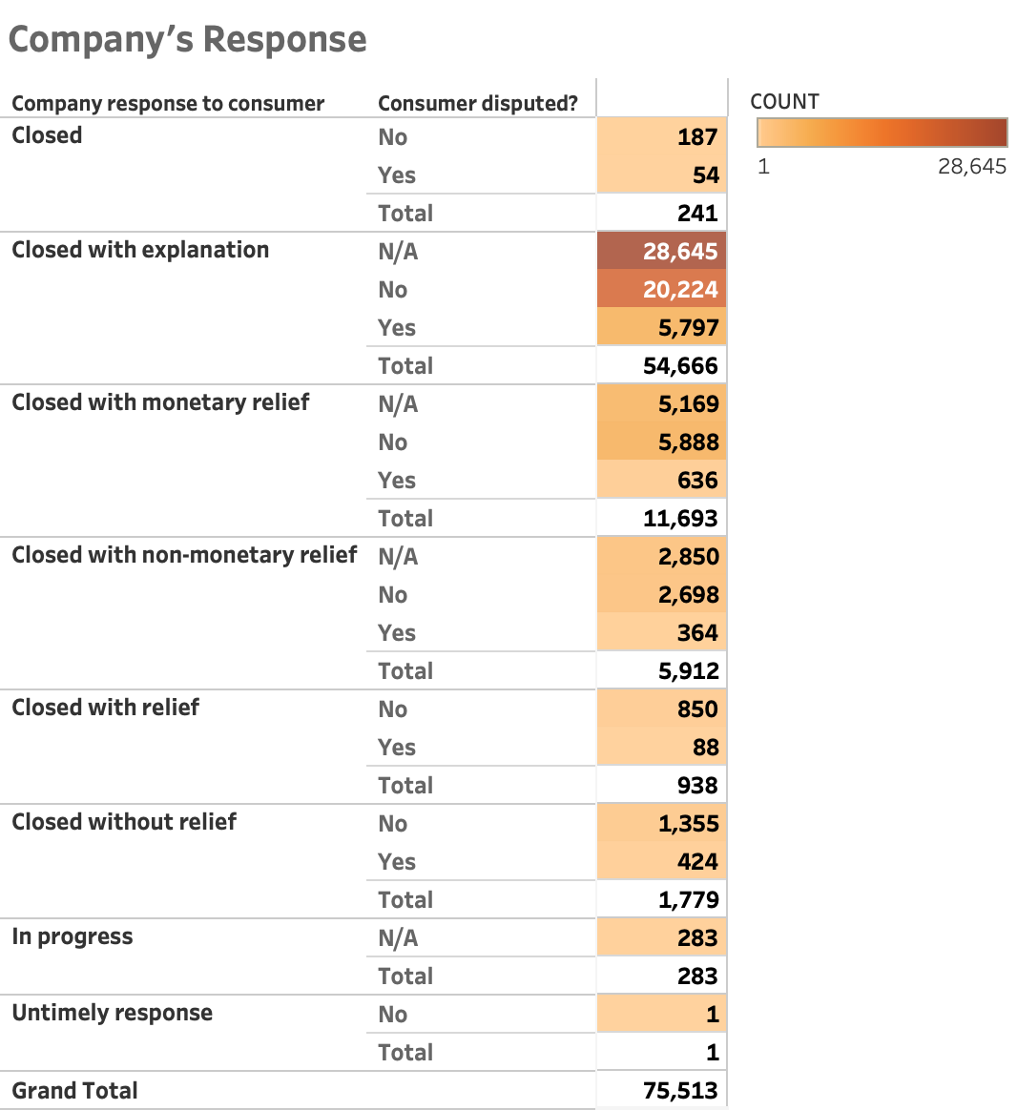

Above Table shows company’s response to customers and the count of each which is further divided under ‘Consumer Disputed?’ column. Consumer Disputed column helps us figure out after the given response by the company how many consumers raised a dispute over the response provided. The table has running totals for each Company response. This table helps us recognize the number of consumers happy with the given responses.
From the above table we can infer that most of the consumers are happy with the response that they get from the company. And they do not raise and disputes later.

4.
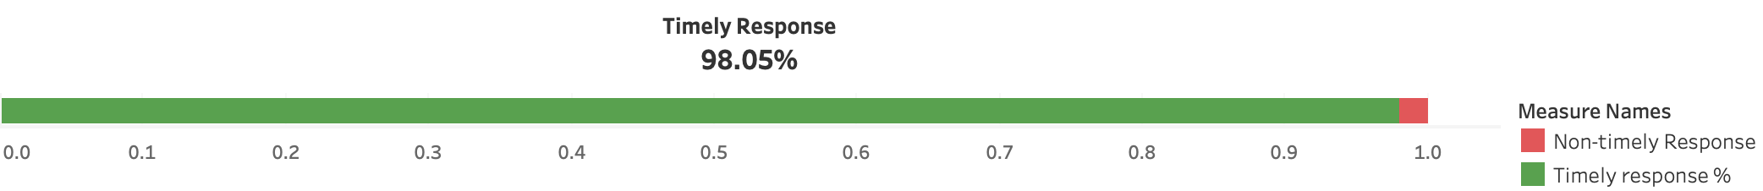

Above bar shows the percentage of timely and untimely responses provided by the company to consumers. This bar helps us monitor the efficiency and performance of the company when we talk about complaints. From the above we can infer that Cumulus financial is doing a good job by responding to complaints raised by consumers in time.

5.
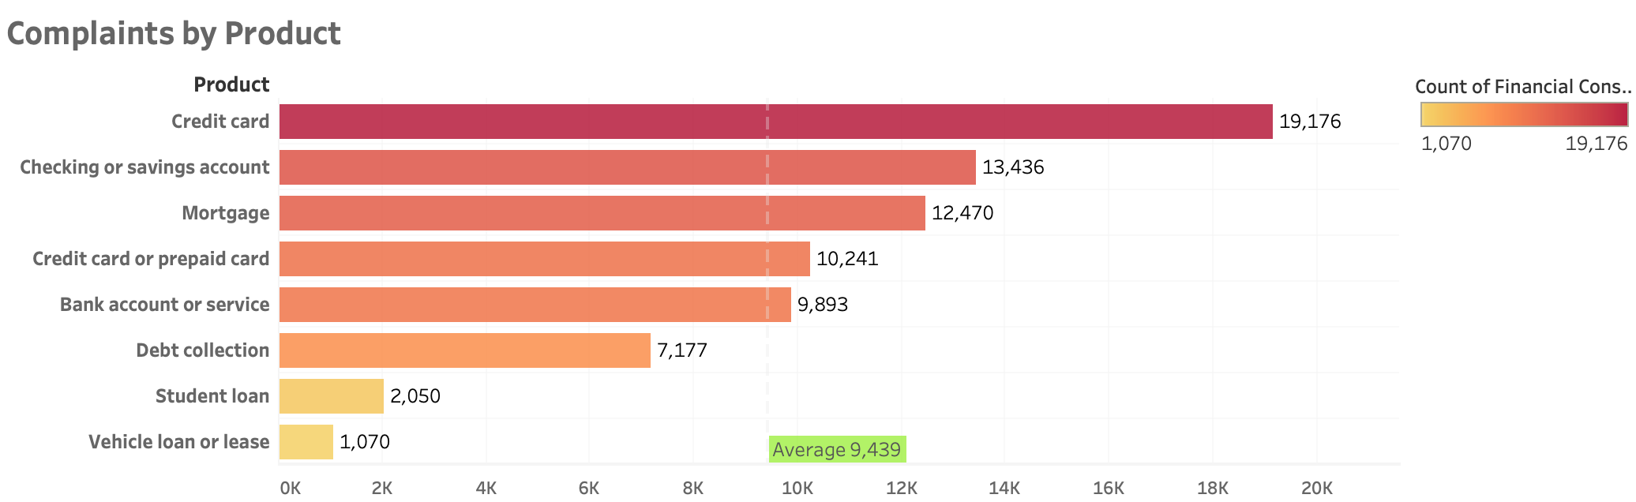

Above bar graph shows Complaints by each Product. This graph helps us recognize the products with which consumers have more complaints and products on which Cumulus Financial needs to focus more. The average line helps us recognize which products are having complaints above average of the total number of complaints. And the products that are performing well and have lesser complaints as compared to average.
From the above we can infer that Cumulus Financial needs to focus on products like Credit Card, Checking and savings accounts, Mortgage, Credit or prepaid cards and Bank account or service.

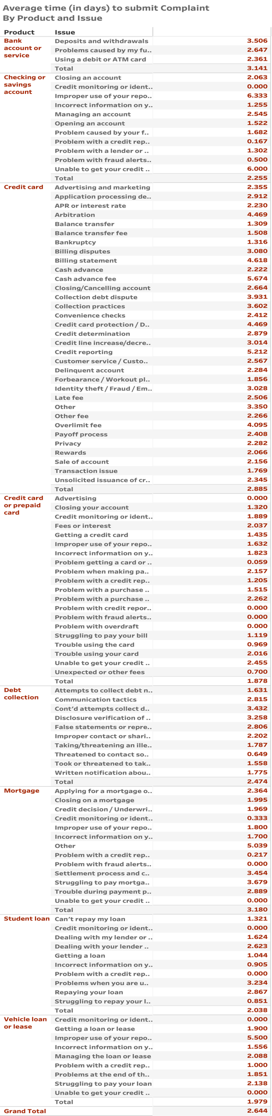
6. This table shows the segregation of each product complaint under different issues and the time (in days) it took for the company to receive the complaint once it was submitted by the consumer. It has a running total for each product. If it takes more days for the company to receive the complaint than it should, then the company needs to check with the system and get it corrected. This will help the company resolve complaints faster and in time.

7.
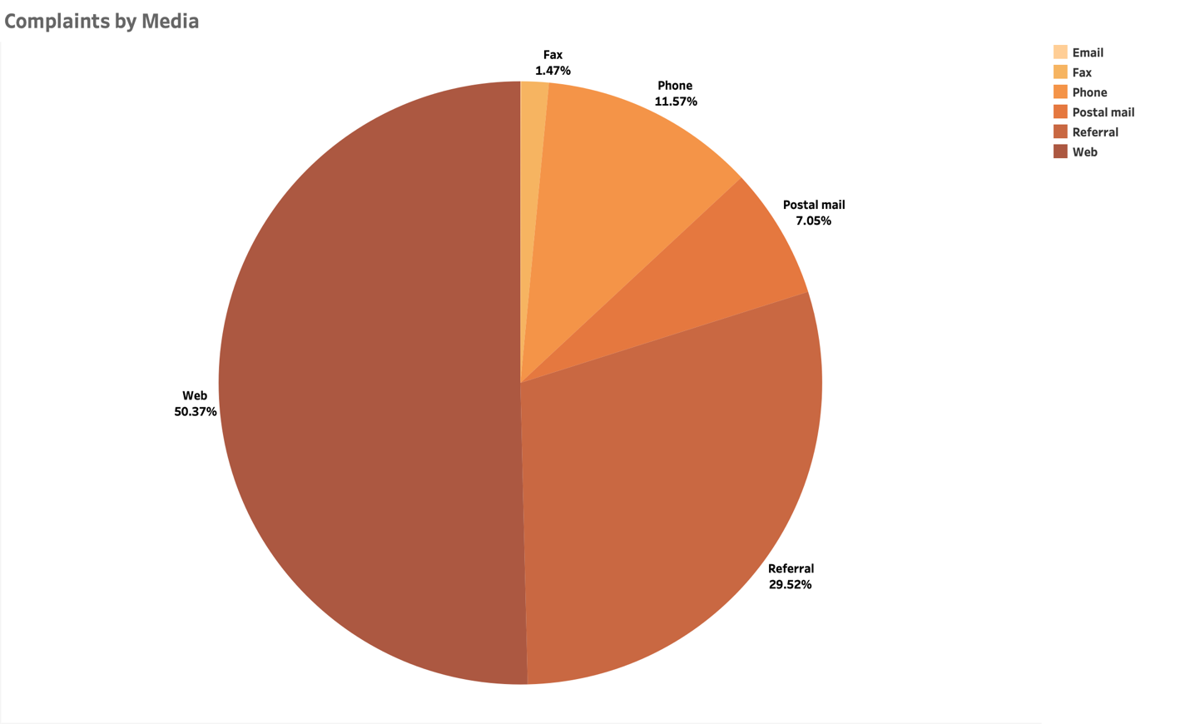
Above Pie chart illustrates the percentage distribution of the media used for submitting the complaints. We can see that more than half of the customers prefer and use web (50.37%) for submitting complaints and Fax is used the least which is just 1.47%.

8.
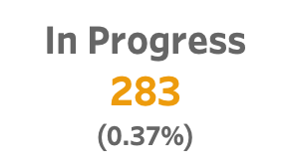

Above card directly gives us the number and percentage of complaints over total number of complaints that are in progress and are yet to be resolved.
The percentage value helps us recognize how many complaints are still pending to be resolved.
From the above card we can infer that there are not many complaints only 0.37% of the total complaints that are in progress. Which is a good indicator of the company’s current status with complaints.

9.
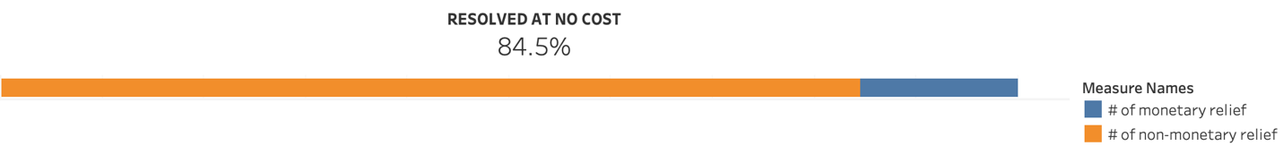

Above card shows us the percentage of resolutions provided by the company at no cost. This is a good indicator of how efficient and satisfying the responses were.

10.
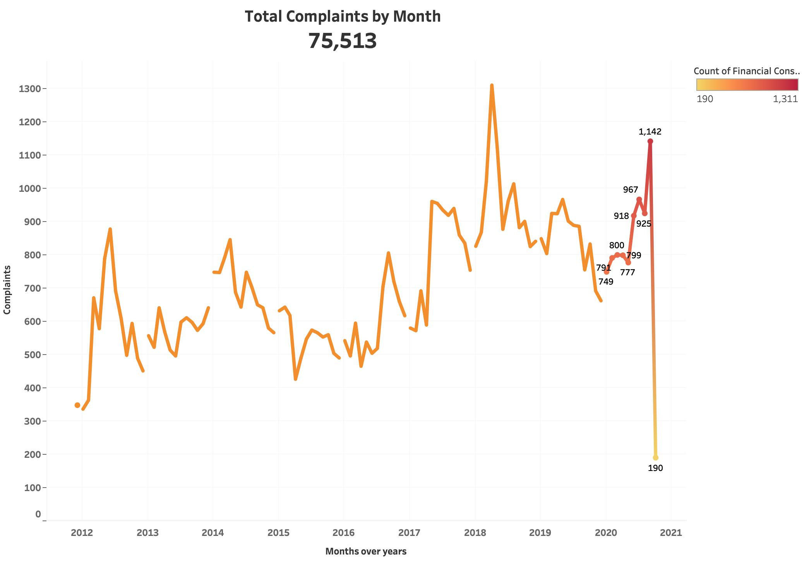

Above line graph shows us the trend in number of complaints over the years. This is a very good indicator of company’s performance. Shows that consumers are not having many issues lately.
We can see that the complaints were lesser in December 2011. Number of complaints were maximum around the time of April 2018 where it reached to around 1300+ complaints in that month. Later in the month of October 2020 is when the company performed the best and had very less complaints only 190 as compared to the previous years.

10. Dashboard 1

In the 1st dashboard we have the distribution of complaints by states. Here the whole dashboard can be controlled/filtered by selecting a particular state on the map. When we select one of the state’s Product wise issue counts gives us an idea of the products wise complaints submitted and what response was provided by the company and how many customers were satisfied with those responses. Also, the card in the bottom right corner shows how many of the issues in that particular state was resolved with no cost.

Below is an example of California state filtered results.

California Example:

11. Dashboard 2
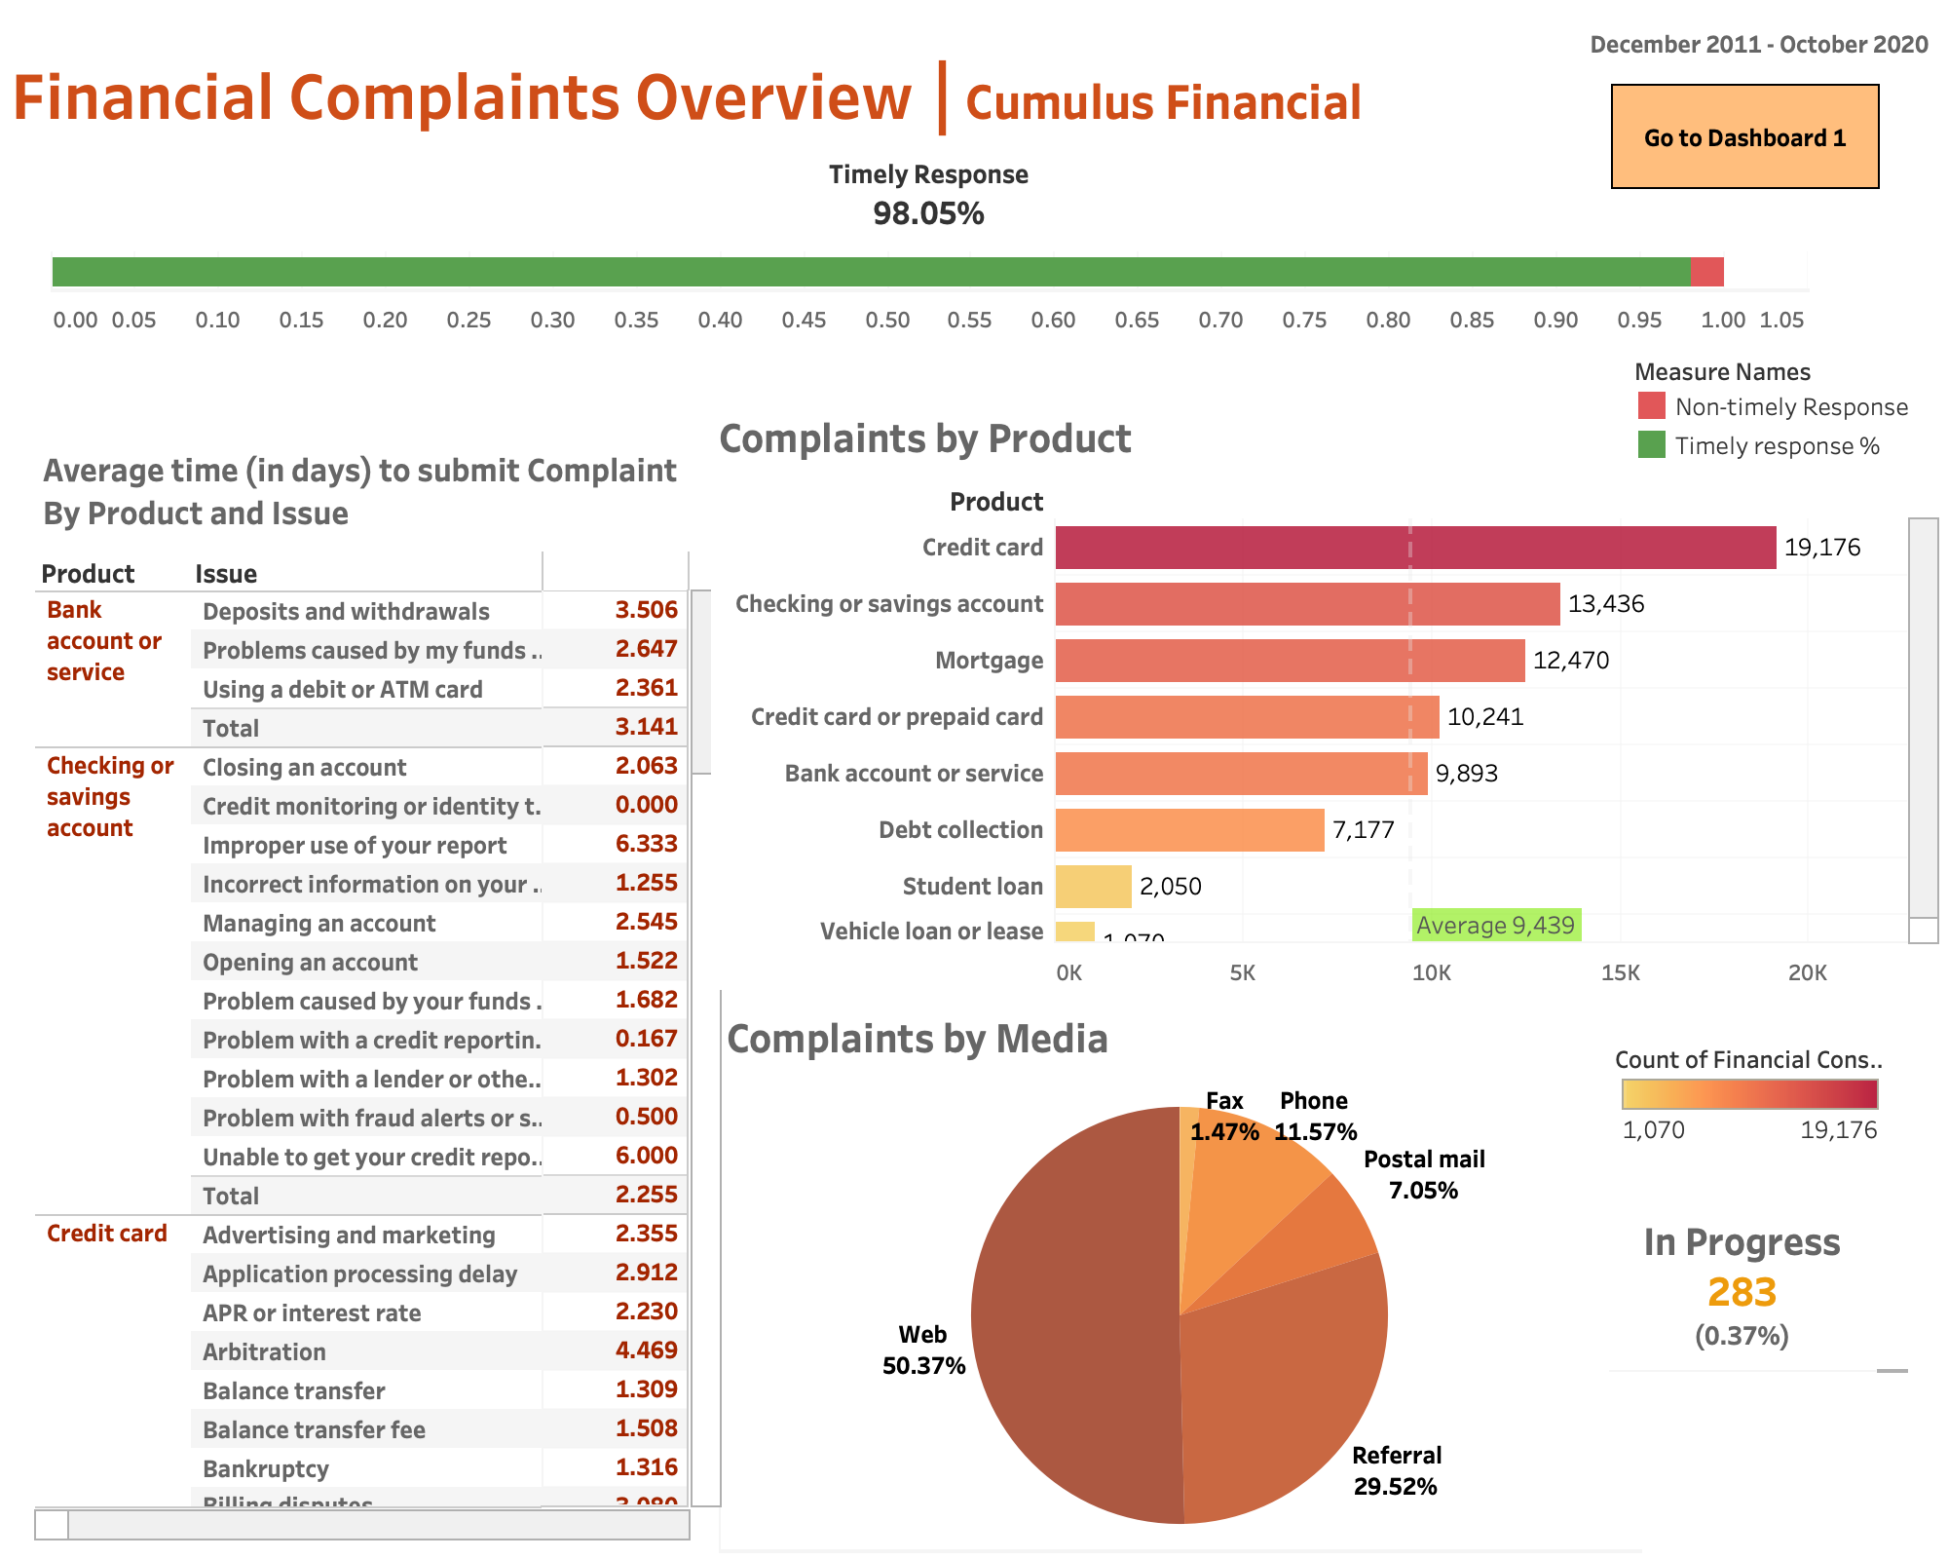

In the 2nd dashboard we can see that the how many of the complaints were responded to in time. This whole dashboard can be controlled/ filtered by selecting the complaints by product bars. For each product we can see that how many responses were given in time. The number of complaints that are still in progress. Average time it took to receive the complaints for that particular product related complaints after they were submitted by the consumer. And in what percentage was each media used to submit those product related complaints.

Below is an example of Checking and savings account filtered results.

Checking and savings account Example:

Dataset URL:
https://data.world/markbradbourne/rwfd-real-world-fake-data/workspace/file?filename=Financial+Consumer+Complaints.csv

